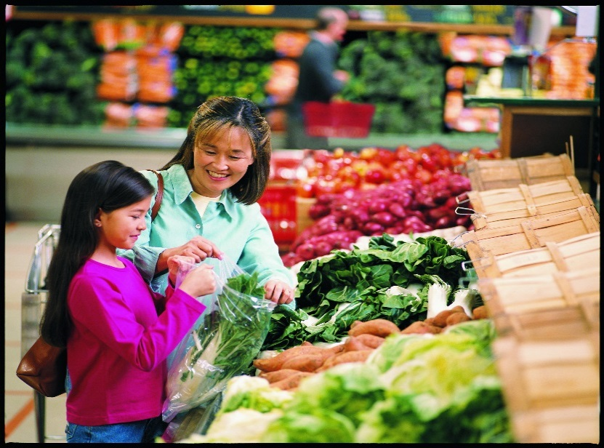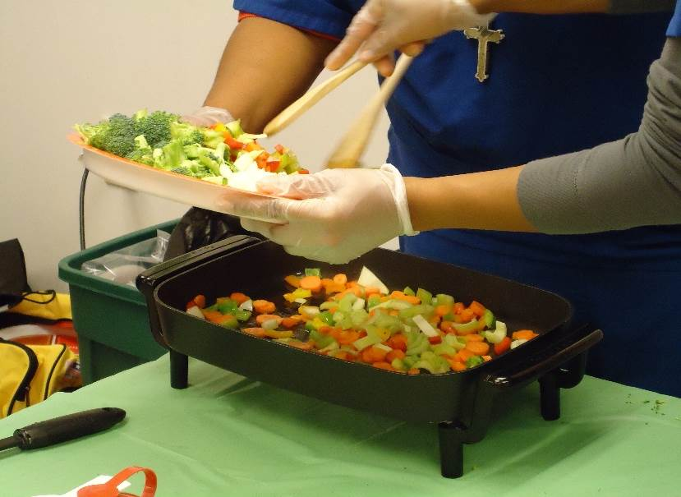

Nutrition Links

Teaching people how to eat better for less!

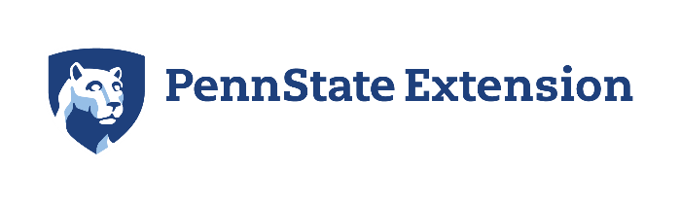Extension_URL_White

In Partnership with:

Beaver County and Butler County

* **Online lessons: 20 minutes each with 6-8 short videos featuring topics, tips, recipes, resources.**
* **Participants work with staff to complete entry and exit paperwork, 6 online lesson topics, and a Food Safety lesson by phone or zoom.**
* **Live zoom lessons & check-ins available.**
* **Certificate of Completion awarded for those who finish within 90 days.**

Topics:

* Smart Size Your Portions
* Choosing to Move More
* Making Smart Drink Choices
* Plan: Know What’s for Dinner
* Shop: Get the Best for Less
* Choosing More Fruits & Vegetables
* Fix It Safe

For more information contact:

1-880-778-3535

This material was funded, in part, by the Expanded Food and Nutrition Education Program (EFNEP), which is supported by the National Institute of Food and Agriculture, U.S. Department of Agriculture, and funded, in part, by USDA’s Supplemental Nutrition Assistance Program (SNAP) through the PA Department of Human Services (DHS). Any opinions, findings, conclusions, or recommendations expressed in this publication are those of the author(s) and do not necessarily reflect the view of the U.S. Department of Agriculture. This institution is an equal opportunity provider. Penn State College of Agricultural Sciences research and extension programs are funded in part by Pennsylvania counties, the Commonwealth of Pennsylvania, and the U.S. Department of Agriculture.

**This publication is available in alternative media on request.**

Penn State is an equal opportunity, affirmative action employer, and is committed to providing employment opportunities to all qualified applicants without regard to race, color, religion, age, sex, sexual orientation, gender identity, national origin, disability or protected veteran status.

During this time of coronavirus, we have new tools available to reach our audience.

Who may participate in this program?

Parent or caregivers of a child 19 and under, adults,   
older adults who qualify for:

Free or Reduced School Lunch

WIC  
SNAP Benefits  
Food Pantry Boxes/Bags

Pennsylvania Farmers Market Vouchers