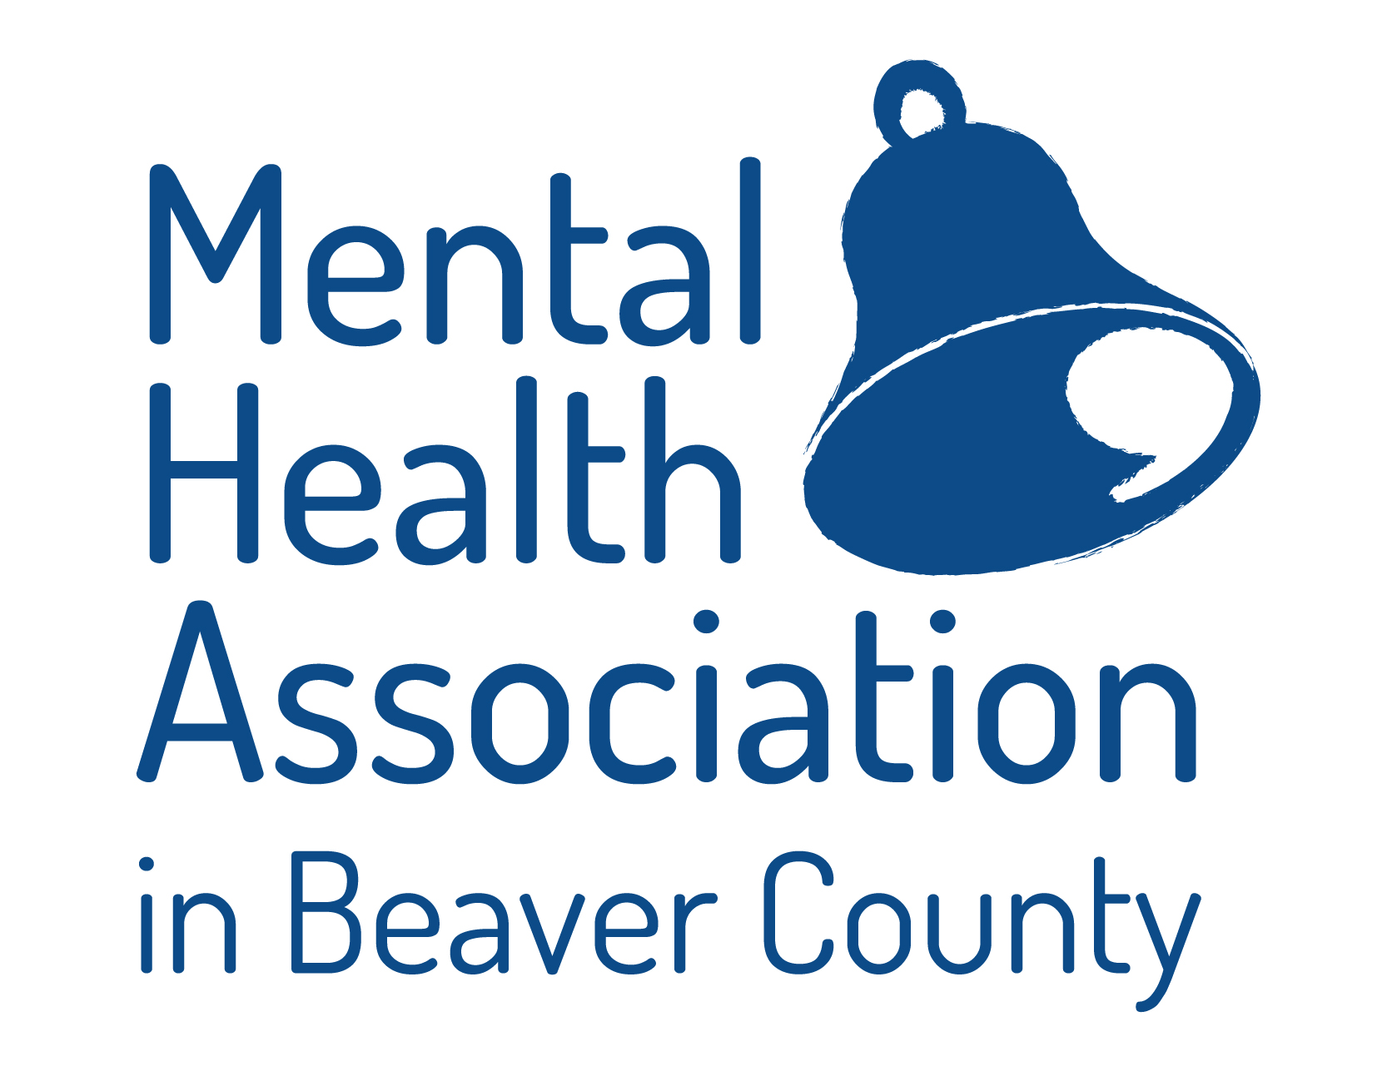

**Our Mission**

The Mental Health Association in Beaver County promotes the importance of mental health by providing advocacy, support, and socialization programs, making a positive impact in the lives of those who strive for improvement in their recovery and quality of life, and by working diligently to change attitudes toward mental illness through education.

Your gift to the Mental Health Association in Beaver County promotes Mental Health and

Fights Stigma through:

\_\_\_In memory of\_\_\_\_\_\_\_\_\_\_\_\_\_\_\_

\_\_\_In honor of \_\_\_\_\_\_\_\_\_\_\_\_\_\_\_\_\_

\_\_\_I would like to volunteer my time to help the Mental Health Association continue its volunteer programs

\_\_\_I would like more information about the Mental Health Association Programs

Please Write Your Tax Deductible Check or Money Order to:

**Mental Health Association**

**105 Brighton Ave**

**Rochester, PA 15075**

**Phone: 724-775-4165**

**Fax: 724-775-8523**

Name: \_\_\_\_\_\_\_\_\_\_\_\_\_\_\_\_\_\_\_\_\_\_\_

Address: \_\_\_\_\_\_\_\_\_\_\_\_\_\_\_\_\_\_\_\_\_

City/State/Zip Code: \_\_\_\_\_\_\_\_\_\_\_\_

\_\_\_\_\_$30.00

\_\_\_\_\_$50.00

\_\_\_\_$100.00

\_\_\_\_\_\_Other

***Join Us !!***

**A multi-service advocacy**

**agency dedicated to serving persons with mental health/co-occurring disorders and their families.**

**105 Brighton Ave**

**Rochester, PA 15074**

**Phone: 724-775-4165**

**Fax: 724-775-8523**

**Email: mha@mhabc.org**

**Website:** [**www.mhabc.org**](http://www.mhabc.org)

**All Services are Provided**

**At No Cost to Residents of**

**Beaver County**

Funds and Resources are Provided by:

**United Way of Beaver County**

**Beaver County Behavioral Health**

**Churches**

**Civic Organizations**

**Schools**

**Individuals**

**C:\Program Files (x86)\Microsoft Office\MEDIA\OFFICE12\Lines\BD10256_.gif**

*MHA in Beaver County is an equal opportunity provider and employer. If you wish to file a Civil Rights program complaint of discrimination, complete the USDA Program Discrimination Complaint Form (PDF), found online at http://www.ascr.usda.gov/complaint filing cust.html. or at any USDA office, or call (866) 632-9992 to request the form. You may also write a letter containing all the information requested in the form. Send your completed complaint form or letter to us by mail at U.S. Department of Agriculture, Director, Office of Adjudication, 1400 Independence Ave. S.W., Washington, D.C. 20250-9410, by fax (202) 690-7442 or email at program.intake@usda.gov.*

**A UNITED WAY MEMBER AGENCY**

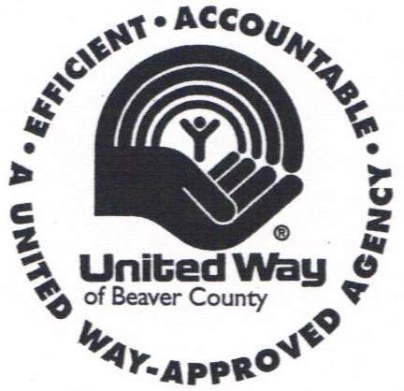

A copy of the official registration and financial information may be obtained from the Pennsylvania Department of State by calling Toll Free within Pennsylvania, at 1-800-732-0999. Registration does not imply endorsement.



For information on open positions or to submit your resume, please visit our Web site at: www.lucernepublishing.com

**\*\*AGENCY PROGRAMS\*\***

**Education**

* **Educational Presentations**: Seminars for the general public and professionals about specific mental health issues.
* **Referral**: Information and appropriate referrals for individuals needing mental health/co-occurring services.
* **Speakers Bureau**: Peer-run Outreach & Education that provides information about mental health recovery and self-help support, such as WRAP®.

**Support Groups**

**Certified Peer Specialists (CPS) of Beaver County:** Monthly meetings where

CPS’s can offer support,

share resources, educational opportunities & network with other CPS’s in the county.

Rebuilders: A peer-run self-help group for adults living with mental health/co-occurring disorders. 

Community Support

Phoenix Drop-In Center: Provides adults a safe and supportive network of recreation, education, volunteer and peer support opportunities.

Health & Recovery Partners: Peer Support Services that provide 1- on- 1 support of educational life management skills & goal planning for individuals with a Serious Mental Illness (SMI), diagnosis to help improve their overall health, quality of life, use of community resources using evidence based practices such as WRAP®, while decreasing isolation & hospitalizations.

Friday Night Friends: Community volunteers who provide friendship, support & activities for individuals receiving mental health/co-occurring services.

Representative Payee: Provides assistance with budgeting, bill paying and managing SSI/SSDI benefits for individuals receiving mental health/co-occurring services.

Peer Mentor: Peers providing support and encouragement to other adult Peers.

Warm Line: Peer-to-Peer non-crisis telephone support that operates 365 days a year, including holidays, from 6 pm-9 pm. 724-775-9507.

Friendship Room: Group social activities held once a month for adults receiving mental health/co-occurring services.

Resocialization: Outreach social programs for adults living in personal care homes.

**Advocacy**

Community Advocate: Provides information and support for individuals concerning rights and responsibilities, recovery, and assistance with accessing community resources.

HealthChoices Ombudsman: Assists individuals and families by providing information about managed care, help with filing complaints and grievances, and support with the appeal process.

Parent/Child Advocate: Provides support and information for families in need of educational, emotional, or behavioral support in a school setting.

C/FST (Consumers/Family Satisfaction Team): Interviews to assess satisfaction with behavioral health services and provides feedback to Beaver County Behavioral Health, managed care, and providers.

Round Table Discussions: Events held in the Drop-In Center, where legislators and stakeholders meet and discuss legislation’s impact on the behavioral health system.

CSP: (Community Support Program): A coalition of local mental health consumers, family members, and professionals who work together with the goal of helping to enrich the lives of individuals so that they may live successfully in the community.

